**Assignment-3**

**DOMAIN:** IOT

**TOPIC:** SMART WASTE MANAGEMENT SYSTEM FOR METROPOLITAN CITIES

**NAME:** MUKHESH KARAN B.L

**REG NUMBER:** 727819TUCS131

**COLLEGE:** SRI KRISHNA COLLEGE OF TECHNOLOGY

**PROGRAM FOR TRAFFIC LIGHT WITH PYTHON CODE**

void setup() {

  Serial1.begin(9600);

  pinMode(21, OUTPUT);

  pinMode(20, OUTPUT);

  pinMode(19, OUTPUT);

}

void loop() {

  digitalWrite(21, HIGH);

  delay(3000); // this speeds up the simulation

  digitalWrite(21, LOW);

  digitalWrite(20, HIGH);

  delay(3000);

  digitalWrite(20, LOW);

  digitalWrite(19, HIGH);

  delay(3000);

  digitalWrite(19, LOW);

}

**OUTPUT:**

**Traffic Lights For Raspberry Pi**

**Blinking Red Light:**

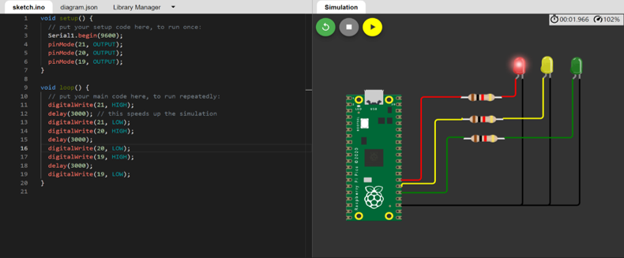

**Blinking Yellow Light:**

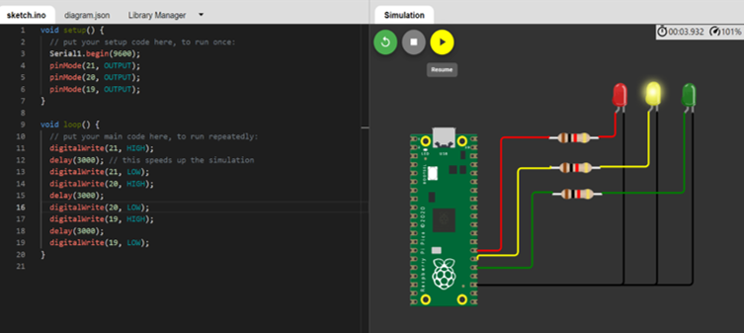

**Blinking Green Light:**

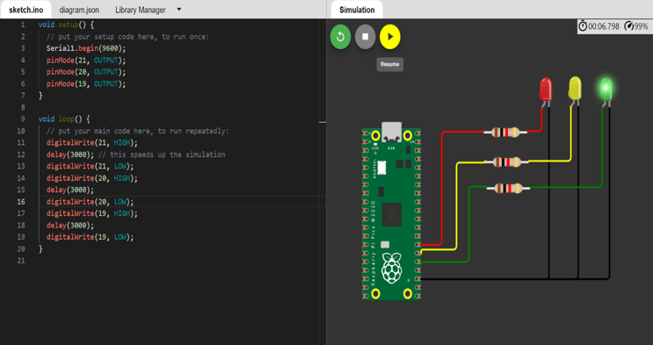

**BLINKING LED:**

**PROGRAM FOR BLINKING LED:**

**Python code:**

void setup() {

  Serial.begin(9600);

  pinMode(22, OUTPUT);

}

void loop() {

  digitalWrite(22, HIGH);

  Serial.println("LED ON");

  delay(2000);

  digitalWrite(22, LOW);

  Serial.println("LED OFF");

  delay(2000);

}

**Output:**

**Blinking LED For Raspberry pi:**

